RIBBLE MEDICAL GROUP

Enhanced Hours Survey Results (11 July 2022)

PAPER SUMMARY
The PCN carried out a patient survey in late June in relation to the introduction of enhanced hours. The key messages from the survey were as follows:

- 4,931 responses were received. This is 12.5% of the registered list size of the practices.
- 60% or patients get to their practice by car and 35% on foot. This suggests a third of patients may struggle to get to appointments at another PCN.
- The top three barriers to access at present are difficulties getting through to the practice by phone (29%) / appointments not being offered soon enough (19%) / telephone triage when patients want face to face service (14%).
- There is a big variety in ease of access across practices. 29% of patients at the best performing practice report no problems accessing services compared to just 4% at the other end of the scale.
- There is a clear preference (45%) amongst all groups for early morning (7am-8am) appointments over other times (22% for the next best option).
- 86% of patients say they would value evening and weekend appointments highly
(this question did not ask the value of morning appointments).
- There is a clear preference for in-person appointments (48%) v other channels. The next favoured option was phone appointments at just 27%.
- 38% of patients would be happy for appointments to be provided at another practice in the PCN and a further 34% of patients may be happy. 28% would NOT be happy and this rises to 37% for patients with disabilities.
- Just 26% of patients would be happy for appointments to be provided by another group of GP practices (i.e. another PCN) with 32% potentially happy. 42% of patients would NOT be happy for appointments to be with another group and this rises to 49% of patients with a reported disability.
- That said, 46% of patients would be prepared to go to another practice within the group for a specialist service and a further 26% to a location within ten miles.
- The top three services patients would find personally useful are Blood Tests (18%), NHS Health Checks (16%) and Medicine Checks and Reviews (9%).
- There is an age difference in the services people would find useful. For 18-24 year olds, their top two preferences are Mental Health Assessments and Mental Health Counselling. From 25 - 44, smear tests are important for woman and from 45 onwards, menopause services are important although these preferences do not show in the top three when filtered by gender.
- The majority of patients (42%) appear to have no preference when it comes to seeing a GP or nurse compared to seeing one of those and having fewer appointments (37%). Patients with disabilities however would rather there be fewer appointments if it means they could see a GP or practice nurse.

- 62% of patients are willing and able to book appointments on line. 20% prefer to speak to someone first.
- 75% are willing and able to manage prescriptions on line with around 10% not knowing how to do this.
- People with disabilities are 10% less willing / able to do manage appointments and prescriptions on line.
- Fewer than a fifth of patients gave 5/5 for their satisfaction level with current appointment provision. There was a marked difference across practices though with the highest scoring practice getting 39% of 5/5s and the lowest getting just 9%.
- This satisfaction gap remains even when looking at the scores for 3/5 + 4/5 + 5/5 combined. The top practice scored 93% and the lowest ranking practice scored 69% which suggests room for improvement as part of the implementation of enhanced access services.
- Across the board, some 28% of patients gave a 5/5 score for the overall care and service. The best scoring practice was rated 5/5 by 53% of their patients. The lowest ranking practice got 18% of 5/5s, again indicating room for improvement.
- With regard to record sharing for appointment booking, nearly a quarter (23% of patients) don’t want anyone other than their practice to see their details.
- Just over half (53%) are happy for other practices in the PCN group to see their details for appointment booking.
- Just 23% are happy for other providers to see their details.
- With regard to record sharing for clinical care provision, just under half (49%) of patients are happy for relevant people within the group to see their medical records.
- Only 24% are happy for anyone who provides services for the group to see their medical records.
- 16% want only their practice to see them and their records.
- These results indicate that we need to manage data sharing and patient consent and involvement sensitively when putting an enhanced hours solution in place.

- 100 pages of patients comments about their current practice were submitted. These have been published separately from this paper.
- A further 36 pages of final comments about anything patients wanted to add were also submitted and again have been published separately.

----------------------------

RIBBLE MEDICAL GROUP

Enhanced Hours Survey Results (11 June 2022)

INTRODUCTION
The PCN is required to carry out a patient survey in relation to the introduction of enhanced hours.
Posters, information sheets and hard copies of an online patient survey were provided to practices following a meeting with Practice Managers on 23 June.

Practices began sending out electronic invites to patients for whom they had text addresses from 24 June onwards. Where practices did not have a text address for a patient, they either sent a hard copy of the survey by post to all or a sample of those patients depending on volumes.

The closing date for the survey was midnight on 07 July

OVERVIEW OF SURVEY
The survey consists of 24 questions.
- Six of these relate to information about the respondent including: registered practice; disability; age group; gender; ethnic group; age group of anyone being cared for.
- The remaining 18 questions related to modes of transport; barriers to access; types of appointment; appointment channels; location of appointments; appeal of different types of appointments; online abilities; current satisfaction levels and general comments.
- There was an error in Q9 which referred to Sat afternoon times as 1pm-3pm rather than 5pm.
- The PCN received 4,931 responses, 12.5% of the registered list size of the practices.

Analysing the data can be time consuming and to assist in the analysis, and to allow practices to do their own analysis if they wish, the PCN has put together an MS Access database which allows the data to be filtered and reports to be produced by any mix of the selection criteria.

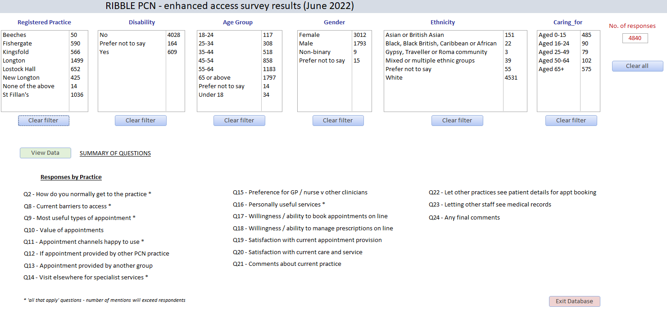

RESPONDENTS
There were a total of 4,931 responses to the survey. Some respondents did not identify one of the PCN practices as their regular practice. The highest response rate was from New Longton patients with the lowest being from The Beeches who were delayed in sending out surveys.

 | Responses | Jan 22 List | %
Beeches | 58 | 2,052 | 3
Fishergate | 594 | 6,456 | 9
Kingsfold | 578 | 4,669 | 12
Longton | 1524 | 10,824 | 14
Lostock Hall | 674 | 5,200 | 13
New Longton | 430 | 1,923 | 22
St Fillan's | 1051 | 8500 | 12
 | 4,909 | 39,624 | 12

- 619 (12.5%) or respondents said they had a disability.
- The largest number of respondents were aged 55 and above (62%)
- 62% of respondents were female, 37% were male. Of the rest, nine people identified as non-binary and 14 people preferred not to say.
- 94% of respondents identified as White, 3% identified as Asian or British Asian. The balance were from mixed ethnic groups or preferred not to say.
- 27% of respondents advised they were caring for people.

Q2 - How do you normally get to the practice *

- 59% (3,519) mentioned car
- 35% (2,081) mentioned on-foot
- No other mode was higher than 3% (185)
- Fishergate had the highest number of respondents who mentioned bus (7% (53).

This suggests that just under two thirds of respondents would be able (but not necessarily willing) to access appointments at another practice or PCN for in-person appointments whilst a third would not.

There were no significant differences when age, gender, disability, and other filters were applied.

Q8 - Current barriers to access *

The largest current barriers to access reported were:
- Difficulties getting through to the surgery by phone - 29% (3,070)
- Appointments offered are not soon enough - 19% (2,016)
- Telephone triage when I need face to face - 14% (1,487)
- Unable to see who I want - 13% (1,393)

- 9% of patients reported not being able to access in normal hours
- 9% had no problems accessing
- A small minority either had no access to online services or didn’t understand how to use these - around 400 people in each group.

There is a difference between practices in how easy it is for patients to access services:

 | % with NO problem accessing services | Top three barriers
New Longton | 29 | Phone / appts not soon enough / phone triage
Kingsfold | 23 | Phone / phone triage / unable to attend in normal hrs (13%)
Beeches | 22 | Phone / appts not soon enough / phone triage
St Fillan's | 10 | Phone / appts not soon enough / phone triage
Lostock Hall | 6 | Appts not soon enough/ phone / unable to see who I want (14%
Fishergate | 5 | Phone / phone triage / appts not soon enough
Longton | 4 | Phone/ appts not soon enough/ unable to see who I want (17%)

- For patients with disability, being unable to see the person they want to see rises to equal third place (with phone triage when the patient needs face to face).
- For patients between 18 and 44, being unable to attend during normal hours is a barrier for around a fifth of patients but declines in older age groups.
- These results are similar regardless of gender, ethnicity or being a carer.

Q9 - Most useful types of appointment * (NB. survey included an error on pm times)

- There is a clear preference across all groups for morning appointments over evenings and Saturdays with between 43% and 48% (48% at Kingsfold and New Longton) favouring these.
- NB. The Saturday PM data could have been skewed by the incorrect opening hours in the question but is unlikely to have changed things much.

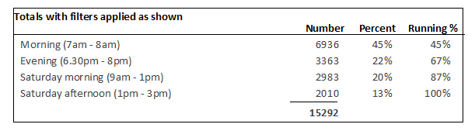
Q10 - How much would you value evening and weekend appointments?

- 86% or patients said they would value evening and weekend appointments highly (59% or with medium value (27%) and 13% valuing them lowly.
- This rises to:
  - 91% at Lostock Hall (H=70%, M = 21%)
  - 90% at Fishergate (H = 65%, M = 25%)

Overall, the results suggest that patients would value enhanced hours services and we need to ensure that the service put in place genuinely provides this.

Q11 - Appointment channels happy to use *
There was a clear preference for in-person appointments:
- In-person 48% (4,809 mentions) - range 45% to 55% (at the Beeches)
- Phone 27% (2,727)
- Video 15% (1,474)
- Email 11% (1,103)

- This preference increased marginally with age.
- Males marginally prefered face to face compared to females.
- People with disabilties favoured in person (50%) but this was largely in preference to video and email.

Q12 - Would you be happy for an appointment to be provided by another PCN practice?

The number of patients who said they would be happy for appointments to be provided at another practice within the PCN was as follows:

 | All | Disability
Yes | 38% | 29%
Maybe | 34% | 34%
No | 28% | 37%

- Patients at The Beeches were most likely to be happy to have an appointment elsewhere (60%) but this could be an artifact of the low number of responses as the range at the other practices was between 36% and 40%.

- Men were slightly more inclined than women to say they would be happy to visit another practice in the group (+3%).
- Willingness for all patients to take an appointment elsewhere declined directly with age -from 53% for 18-24 year olds to 36% for those aged 65 and above.
- People with disabilities were much less inclined (-9%) to say they would be happy for an appointment at another practice.
- Asian and British Asians were less inclined to be happy (-3%) than ethnic whites.
- People caring for others over school age were generally less happy going elsewhere.

Q13 - Would you be happy for an appointment to be provided by another group of GP practices?

The number of patients who said they would be happy for appointments to be provided by another group of GP Practices was as follows:

 | All | Disability
Yes | 26% | 18%
Maybe | 32% | 33%
No | 42% | 49%

- Women were less likely than men (-4%) to want to go to another group.
- There was a general reduction with age to go elsewhere
- People caring for others became less happy going elsewhere as the age of those they care for increased.
- There was a clear preference amongst people with a disability NOT to go elsewhere.

Taking the answers from Q12 and Q13, there is a clear preference for appointments to be provided within the PCN (38%) compared to by another group (26%) and this is particularly the case where patients report having a disability (29% v 18%).
Q12. Would you be happy for an appointment to be provided by another GP Practice in our Group?
Q13 . Would you be happy for an appointment to be provided by another group of GP practices?
 | Q12 - Provided by our Group |  | Q 13 - Provided by another group
Happy | All | Disability | All | Disability
No | 28% | 37% | 42% | 49%
Maybe | 34% | 34% | 32% | 33%
Yes | 38% | 29% | 26% | 18%

Q14 - Would you be prepared to go elsewhere for a specialist service? *
Patients’ willingness to go elsewhere for services increases when this is for specialised services although there is still clearly a preference for this to be with a practice within the PCN.

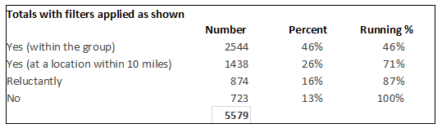

Q16 - Which of the following would you find personally useful * (Deliberately non-sequential)
When asked which services patients would find personally useful, the top three at every practice included:
- Blood tests
- NHS health checks
- Medicine checks and reviews.

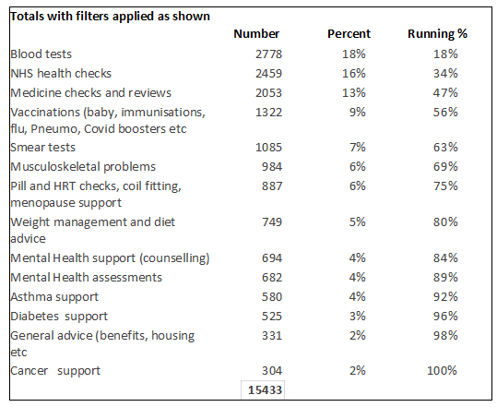

There was a difference in preferences when the data was analysed by age group (although this difference was not reflected when filtered by gender):

18-24 yrs | Mental health assessments / counselling / blood tests
25 - 34 | Blood tests / smear tests / NHS checks
35-44 | Smear tests / blood tests / NHS checks
45 - 54 | Blood tests / NHS checks / Menopause services

Q15 - Preference for GP / nurse v other clinicians

The majority of patients (42%) appear to have no preference when it comes to seeing a GP or nurse compared to seeing one of those and having fewer appointments (37%)

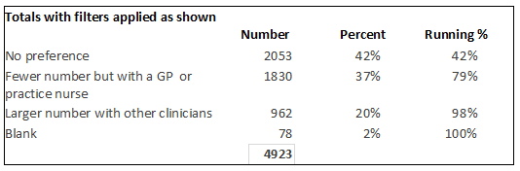

- Patients with disabiilties have a clear preference (46%, +9%) for fewer appointments but with a GP or practice nurse.

Q17 - Willingness / ability to book appointments on line

A majority of patients said that they were willing and had the ability to book appointments on line. With the right IT in place and appropriate support for those who do not yet know what is possible, this could be a real asset to the management of the enhanced hours service.

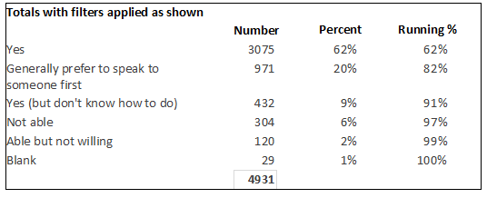
- That said, those willing and able to book appointments on line drops to 51% for those reporting a disability, with the main reason for the drop being due to not being able.
- There was no significant drop with age although the 65+ were slightly less willing / able due to an increased preference to speak to someone first.

Q18 - Willingness / ability to manage prescriptions on line

An even higher percentage of patients than for appointments said that they would be willing and able to manage prescriptions on line. There is a clear potential here for helping patients do even more for themselves in this area.

Patients with a reported disability again showed a 10% lower level of willingness / ability to do things online.

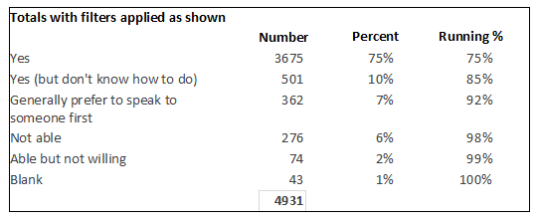

Q19 - Satisfaction with current appointment provision

Fewer than a fifth of patients said they were very happy (5/5) with the current appointment provision and fewer than half scored current provision as a 5 or a 4. Whilst it will never be possible to please everyone all of the time, the survey suggests there is an opportunity for improvement when implementing enhanced hours.

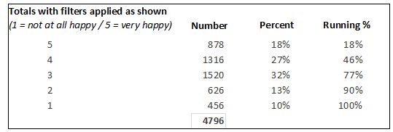

 | 5/5 scored | 5 + 4 scored | 5 + 4 + 3 scored
New Longton | 39% | 76% | 93%
Kingsfold | 38% | 71% | 92%
Beeches | 33% | 61% | 88%
St Fillan’s | 18% | 47% | 79%
Fishergate | 15% | 38% | 74%
Lostock Hall | 12% | 37% | 74%
Longton | 9% | 34% | 69%

- There is no significant difference between those with disabilities and those without scoring 3 and above on satisfaction with current appointment provision..
- There is no significant gender or age difference either.
- 67% of Asian and British Asian respondents score current provision at 3 or above compared to the average of 77%. This could indicate their needs are not being met as well as other populations, or potentially, that they have different expectations to other groups.
- There is no significant difference in satisfaction levels amongst those caring for others.

Q20 - Happiness with overall service and care provided current practice

New Longton and Kingsfold were rated most highly by patients for overall care and service when measured on the number of 5’s / 4’s + 5’s / 3’s+4’s+5’s scored.

Across the board, 4/5ths of patients thought that their practices scored 3 or above in terms of overall service and care which probably suggests solid foundations with room for improvement.
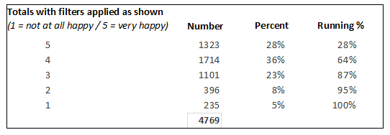

 | 5/5 scored | 5 + 4 scored | 5 + 4 + 3 scored
New Longton | 53% | 87% | 96%
Kingsfold | 52% | 81% | 95%
Beeches | 30% | 61% | 84%
St Fillan’s | 24% | 62% | 87%
Fishergate | 22% | 53% | 81%
Lostock Hall | 23% | 62% | 88%
Longton | 18% | 57% | 82%

Q21 - Sample Comments about current practice
The full set of comments about practices runs to 100 pages and is available in a separate report.

Like most surgeries(not just mine) these days I wish I could have an appointment long enough to get all the ailments I need help with out in one go instead of coming away feeling like a nuisance and dissatisfied and then I'll off what's wrong with me to the point it can end up worse than it is now. Can't surgeries offer one to one appointments for half hour to an hour? I'm so fed up of feeling like I'm not heard and I'm getting nowhere or only half way there. Also some receptionists make me feel like I'm a real nuisance also and question and lecture me and sometimes I'm that frustrated and upset I come home and cry. I understand I'm a complex case with many, but mostly minor ailments, but my health conditions stop me living a normal life and I just wish surgeries had the time to help me sooner. It takes tears sometimes before I get the help I need.

Amazing professionals who are there for us when we need them!

Clean and efficient

I don't like having to explain on the phone why I need an appointment to receptionist because I know people in the waiting room can hear her discussing my problem and using my name

Sometimes difficult to arrange a face-to-face appointment or arrange a telephone consultation with my GP. Reception staff seem to try and put barriers in the way and appear to be making an assessment of my needs when I am not confident they are qualified to do so. My Type 1 diabetes is managed by the Manchester Diabetes Centre but there seems to be little communication with them on my behalf when for example I have blood tests undertaken by the practice and it’s left to me to obtain my results and send them to the Manchester Diabetes Clinic myself. Very odd.

Much improved recently.

Having previously been registered with a larger GP practice, once I experienced the personable service provided by a smaller practice I wouldn't want to change that now. New Longton practice is by far the best practice I've ever used from the receptionists to the GP's, the practice nurse and phlebotomy service. I have always been treated as though I am the only patient in the practice despite it always being very busy. My desire for evening & weekend hours is based on my working hours rather than an inability to get an available appointment if/when required.

Best Dr’s in Preston area :)

The best in GB

MEDICAL RECORDS AND INFORMATION SHARING
Q22 - Happy to let other practices see your details for appointment booking

The picture on who patients would like to be able to see their records for appointment booking is mixed:

- Nearly a quarter of patients don’t want anyone other than their practice to see their details.
- Just over half are happy for anyone within the PCN to see their details for this purpose.

- Nearly a quarter are also happy for other providers to see their details.

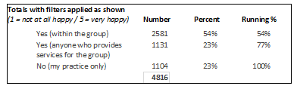

- There is an age difference here. Around 30% of 65 and over patients would not want other practices in the PCN or elsewhere to see their data for appointment booking.

Q23 - Happy to let clinical staff at other practices see your medical records so they can provide informed care and support (You can still have an appointment without agreeing to this if you wish).

The picture on who patients would like to be able to see their clinical records as part of the provision of care is also mixed with slightly fewer patients being willing for their medical records to be shared than for their details to be used for appointment booking:

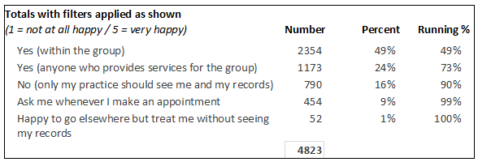

Combining the results from Q22 and Q23,

 | For booking appts  (admin details) | For care and support  (medical records)
Yes (within the group) | 54% | 49%
Yes (anyone who provides services for the group) | 23% | 24%
NO (my practice only) | 23% | 16%
Ask me whenever I make an appointment |  | 9%
Happy to go elsewhere but treat me without seeing my records |  | 1%

Q24 - Sample final comments

The full set of final comments about practices runs to 36 pages and is available in a separate report.

This looks like a good initiative

Some of my answers have been influenced by my experience with one of the other practices within the group - my elderly parents’ GP surgery. My experience with this practice has been very poor in comparison to my own GP surgery, and I would be reluctant to have this practice involved in my own family’s care.

Not everyone in my age range i.e. 77 is comfortable using online services!!

On behalf of my wife, family & myself I would just like to take this opportunity to thank all the Dr’s & staff at this practice, for all their help, care & kindness over the many past years.

I think it is extremely important that you have a good relationship with your GP so if you are struggling with physical or mental health problems you are comfortable in discussing them

I do prefer my own practice. But I understand the need for all the GPS in our local area to work together to provide healthcare services locally.

GDPR is a legal requirement. Having to discuss personal issues and information with a receptionist who can be heard by everybody in the waiting room, is wrong. They often use the person's name and condition in the telephone conversation. As a patient, we should not have to go into detail with a non-qualified medical person.

There was no option for ‘by wheelchair’ for how I get to the practice so I put prefer not to say. There was no ‘other’ and some answers did not have an option I could choose at all.

People with specific learning disabilities and mental health issues, that have been confirmed and diagnosed perhaps should be looked at as a group of people who will have more health issues, meaning more visits overtime. A wider range of tests and options for these people would reduce the need for multiple appointments. Perhaps a regular or yearly overall health check-ups would be beneficial. Also I have ADHD and struggle with my teeth. I probably have an infection in my gum but I can’t for the life of me seem to get on the list for an NHS dentist. So I end up going to an emergency dentist when it gets bad, perhaps local dentists and GPs can work together to help people who struggle with this issue. Other than that the GPs and the surgery (Fishergate) are absolutely fantastic.

An Excellent initiative just hope it leads to a better patient outcome. Good luck with that

Dave Price
11 July 2022
--------------------

Some questions (2, 8, 9, 11, 14,16) allowed people to make multiple selections. The total number of responses for these questions will therefore exceed the total number of respondents. *

